Virtual Private Network (VPN) Lab

NAME: JASHWANTH REDDY GANGULA  
SUID: 646254141

1 Overview

VPN is built either over IPsec or TLS/SSL layer. In this project, we will use the approach of TLS/SSL layer.

2 Lab Environment

In this lab, we will explore how to write tun/tap programs.

How to use route and ifconfig commands.

How to use the route and ifconfig commands.

How to use VM to setup network for several VMs

3.1 Task 1: VM Setup

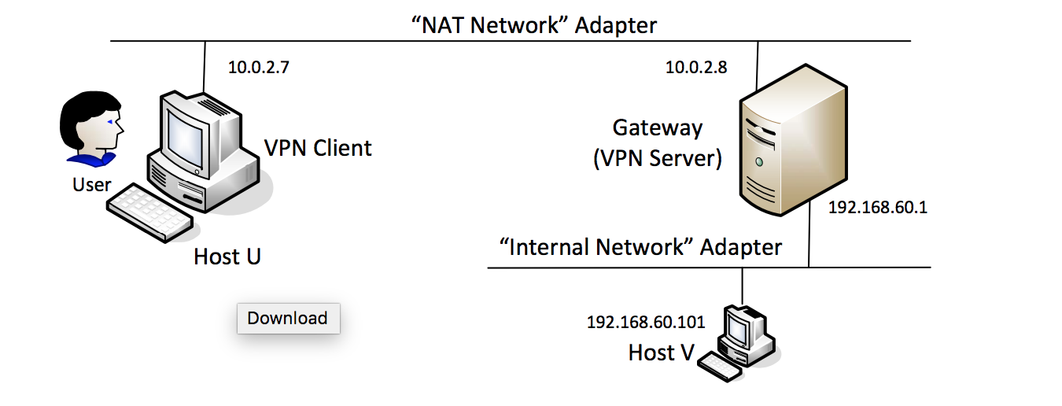

We use the setup as shown in the figure above. The client, VPN gateway are connected using NAT network adapter. This simulates the real world internet connection between them. The HostV and Gateway are connected using Internal Network Adapter. This simulates the private network of an organization. VM doesn’t provide any DHCP for internal network, so we need to configure static IP address as shown in the figure below.

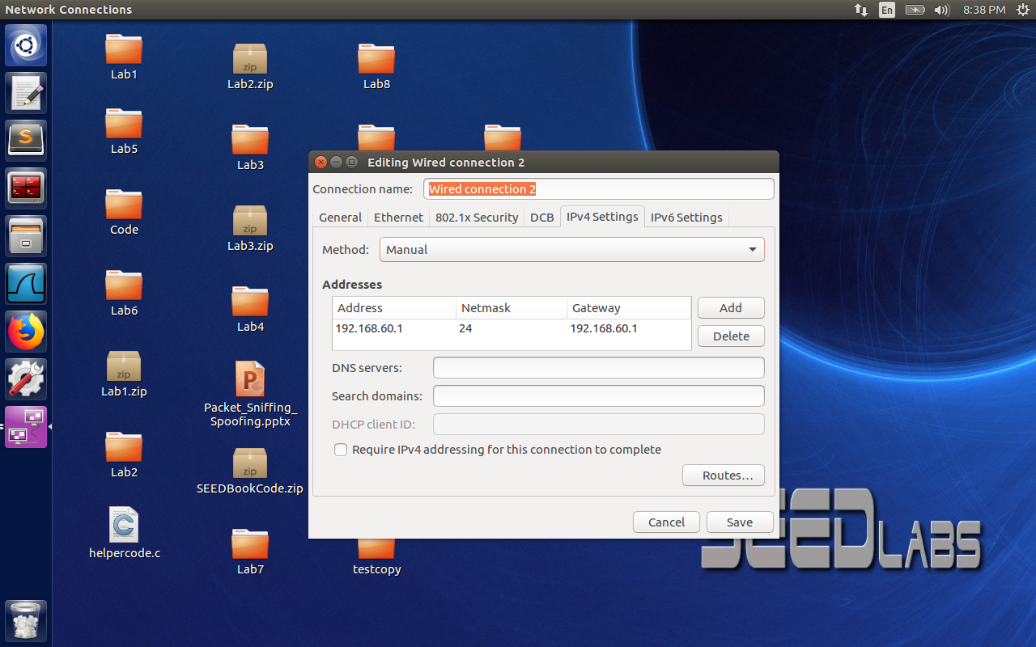

The figure is for VPN gateway configured with IP address 192.168.60.1 which is same as the gateway IP address.

3.2 Task 2: Creating a VPN Tunnel using TUN/TAP

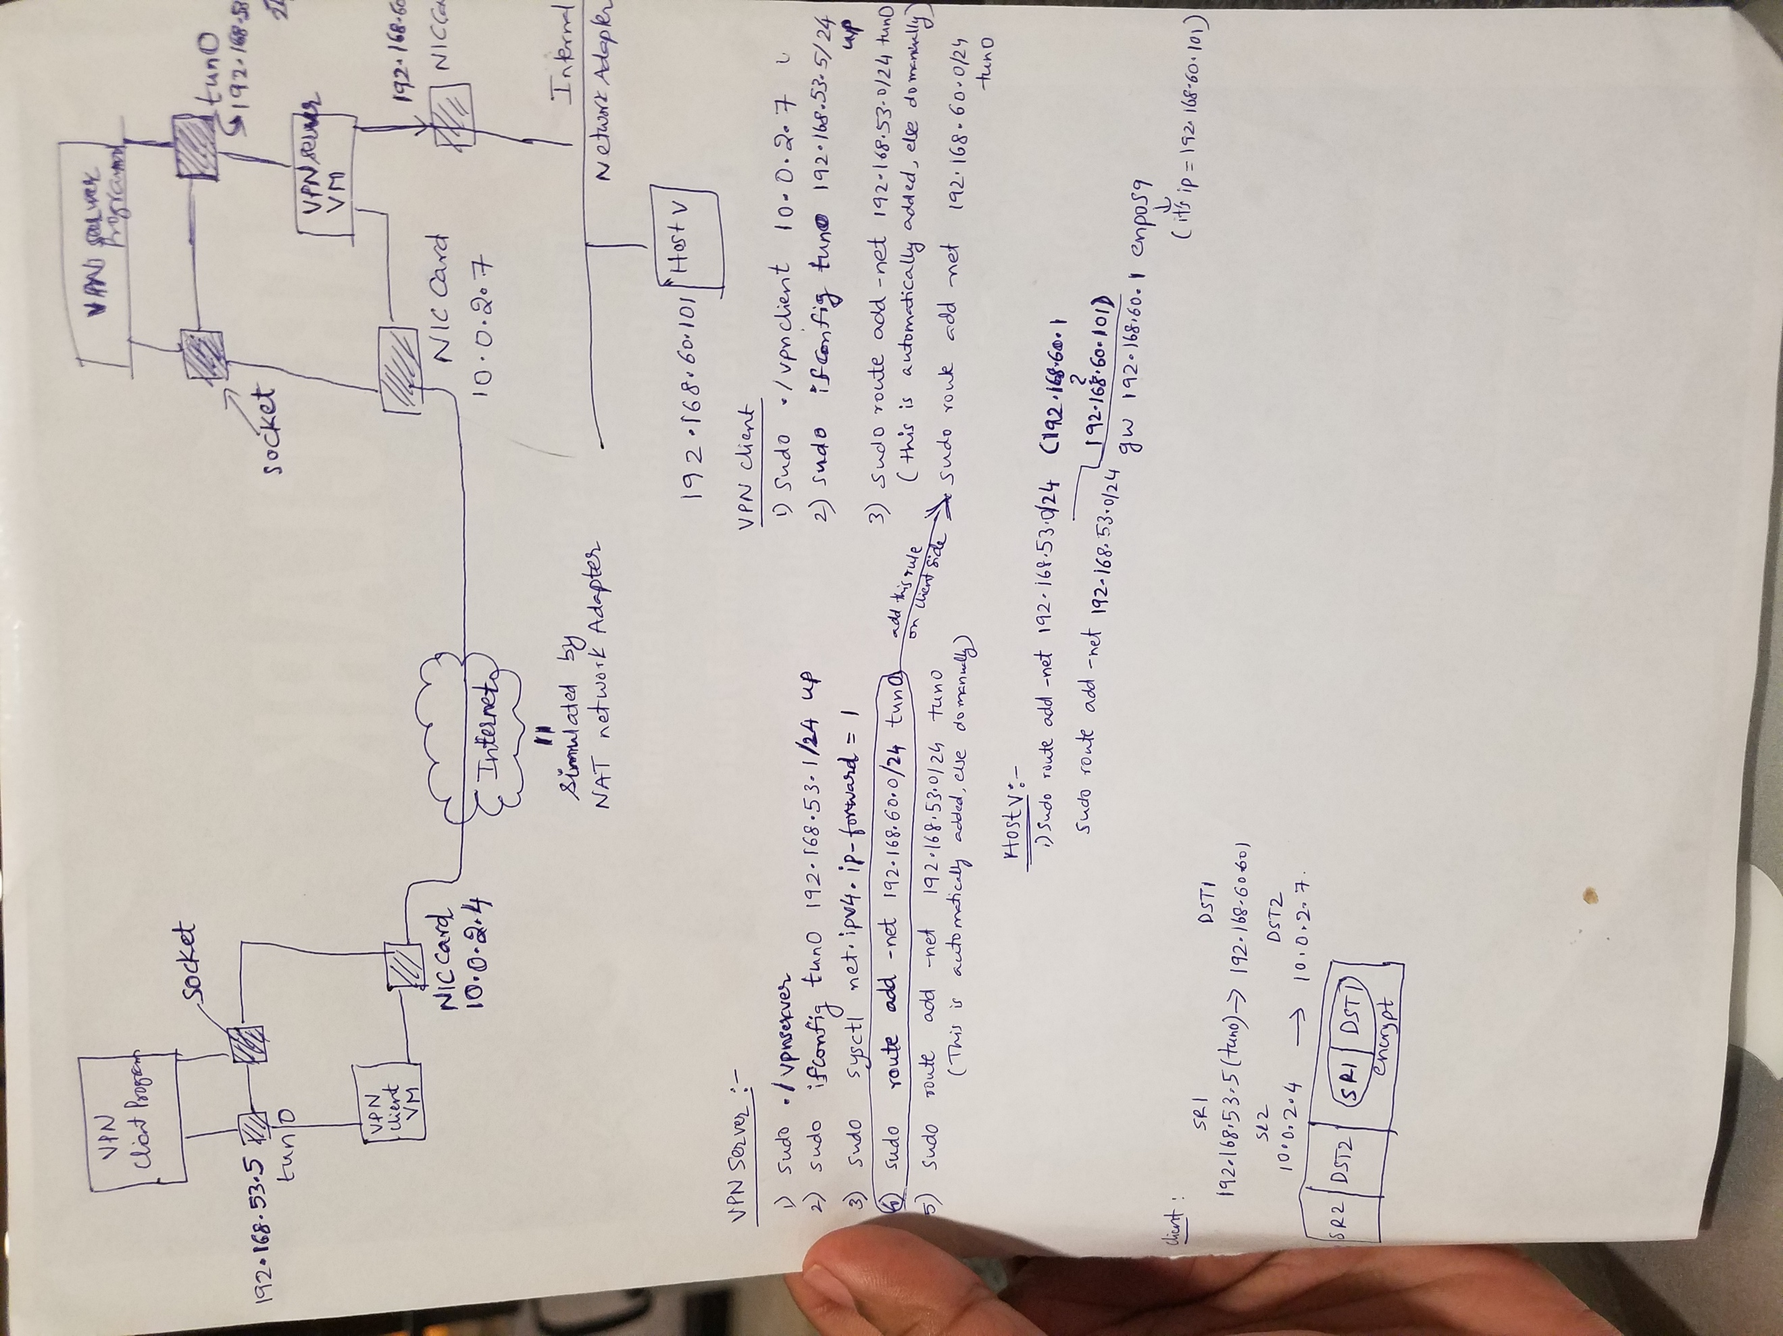

So I have configured the below commands on the server side:

Step 1: Run VPN Server

1)sudo ./vpnserver

Go to another window and execute the below commands

1)sudo ifconfig tun0 192.168.53.1/24 up

2)sudo route add –net 192.168.53.0/24 tun0

3) sudo sysctl net.ipv4.ip_forward=1

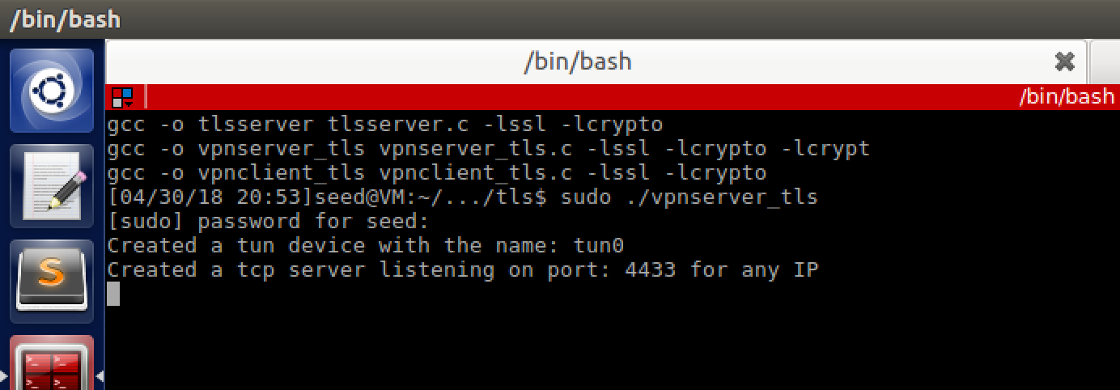

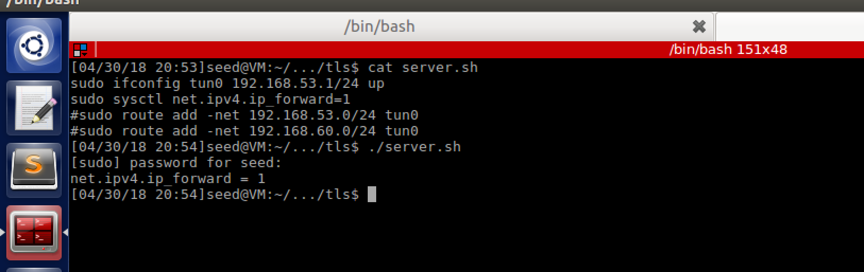

Step 2: Run VPN Client.

Client:

1)sudo ./vpnclient “gangula.com” 4433

Open another window and execute the below commands

1)sudo ifconfig tun0 192.168.53.5/24 up

2)sudo route add –net 192.168.60.0/24 tun0

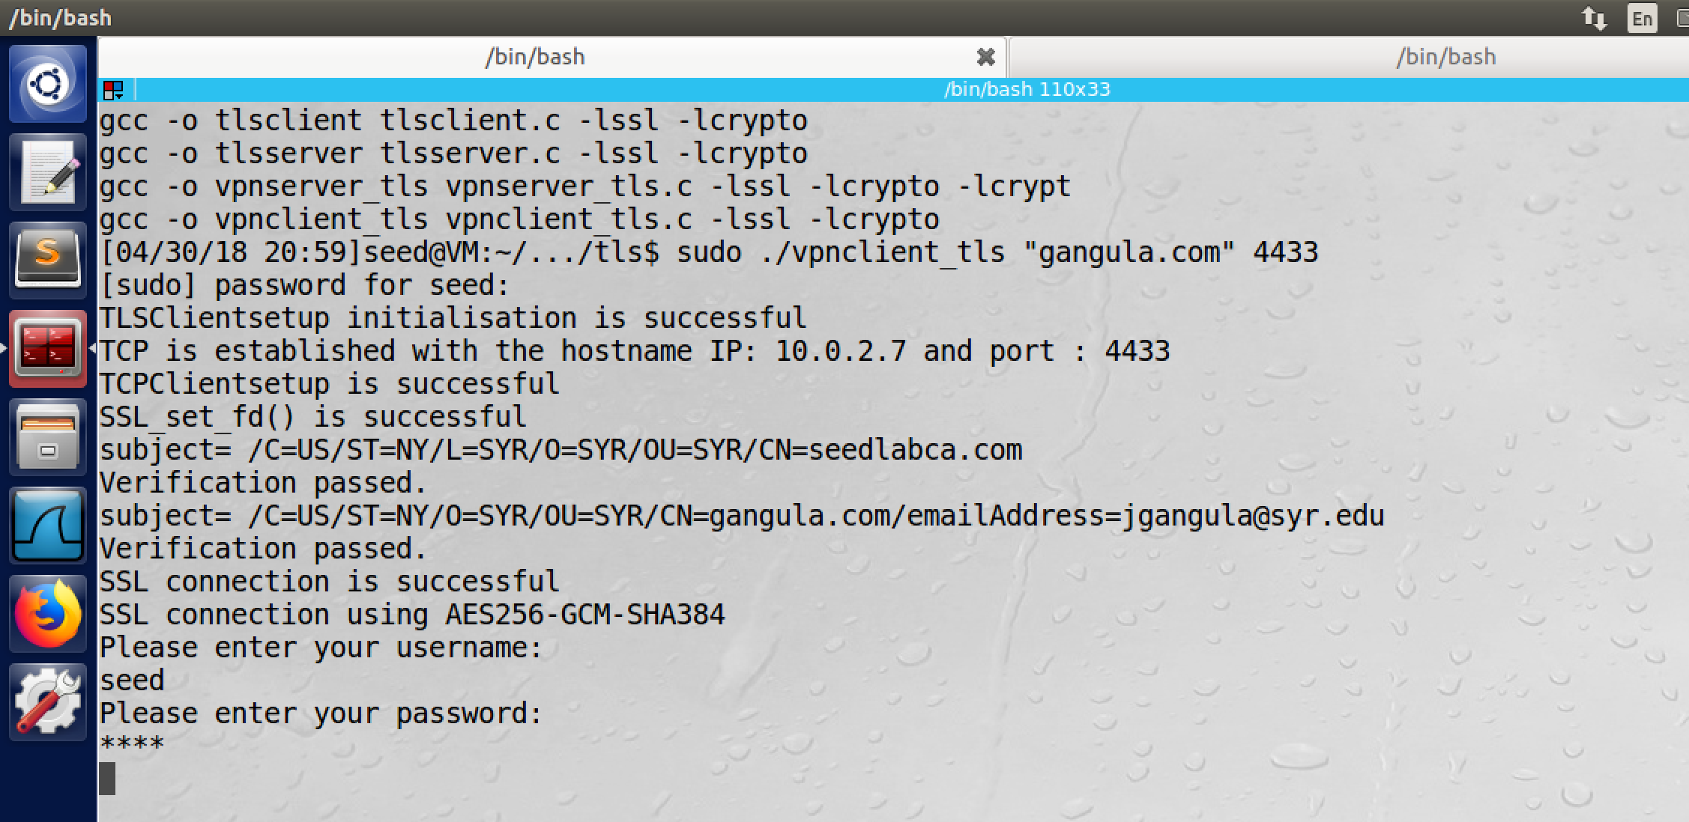

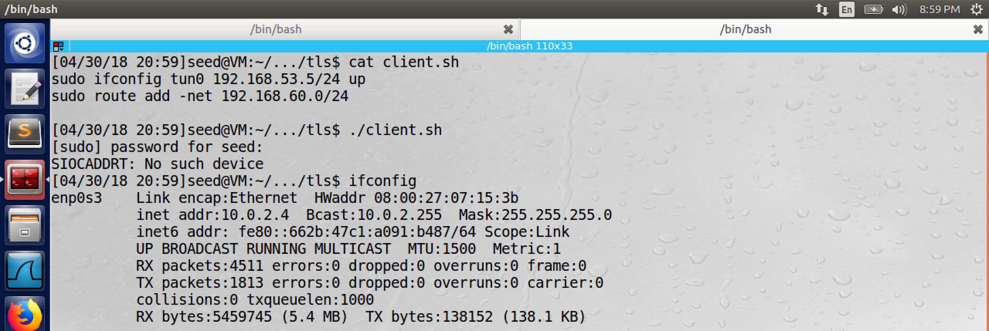

Step 4: Set Up Routing on Host V

1)sudo route add –net 192.168.53.0/24 gw 192.168.60.1 enp0s9

(Here IP address of enp0s9 is 192.168.60.101)

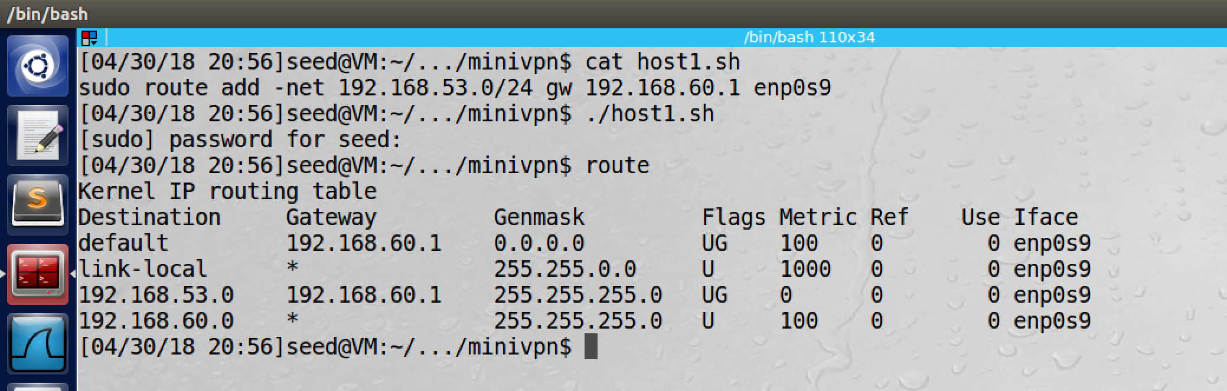

Step 5: Test the VPN Tunnel:

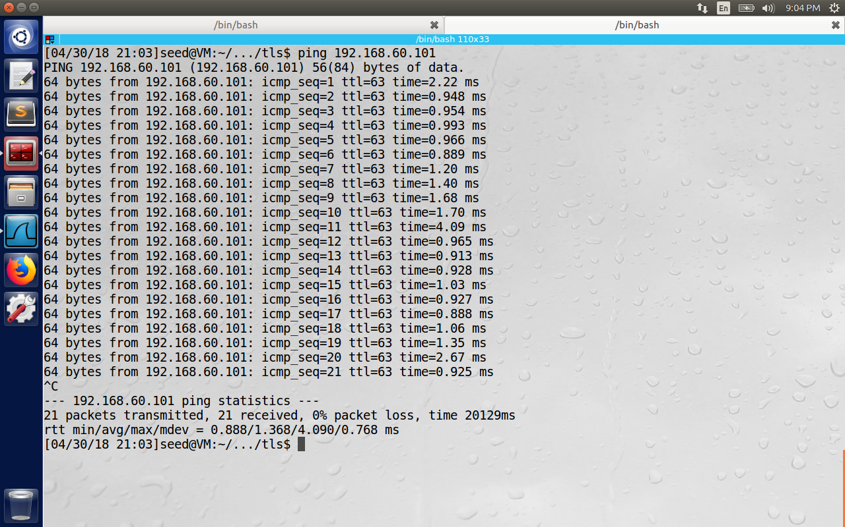

I have also captured the packets in Wireshark to show that they are sent through the encrypted channel (TLS 1.2)

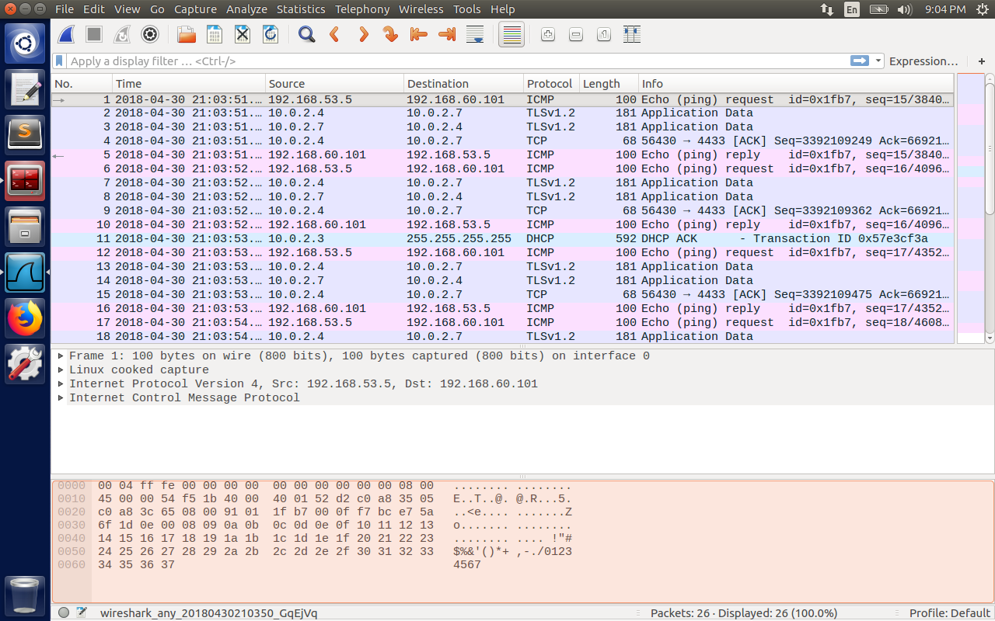

Step 6: Tunnel-Breaking Test.

Now I have pressed on Ctrl+C command on the client side. The connection was terminated and

The telnet session was not responding to the user input.

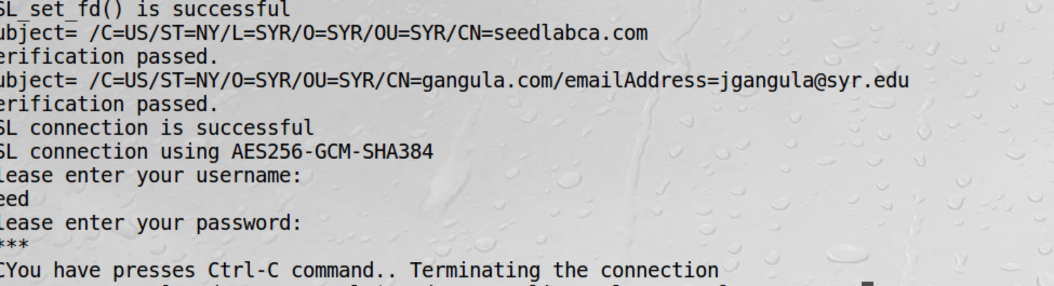

This is the telnet session (observe the IP as 192.168.60.101of host machine for proof). It stopped responding after breaking the tunnel .

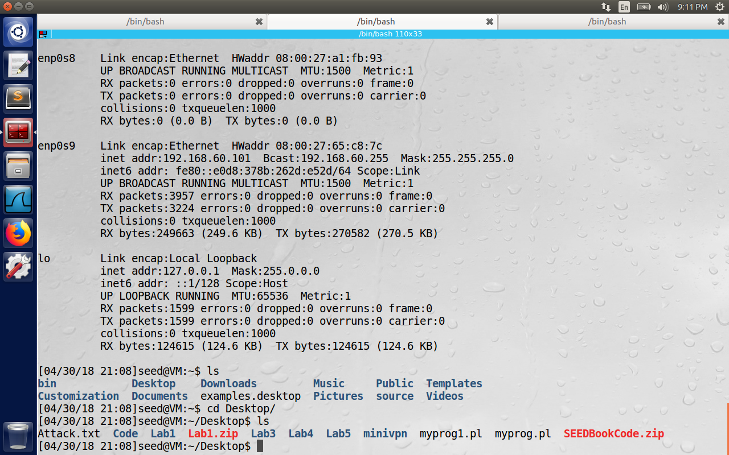

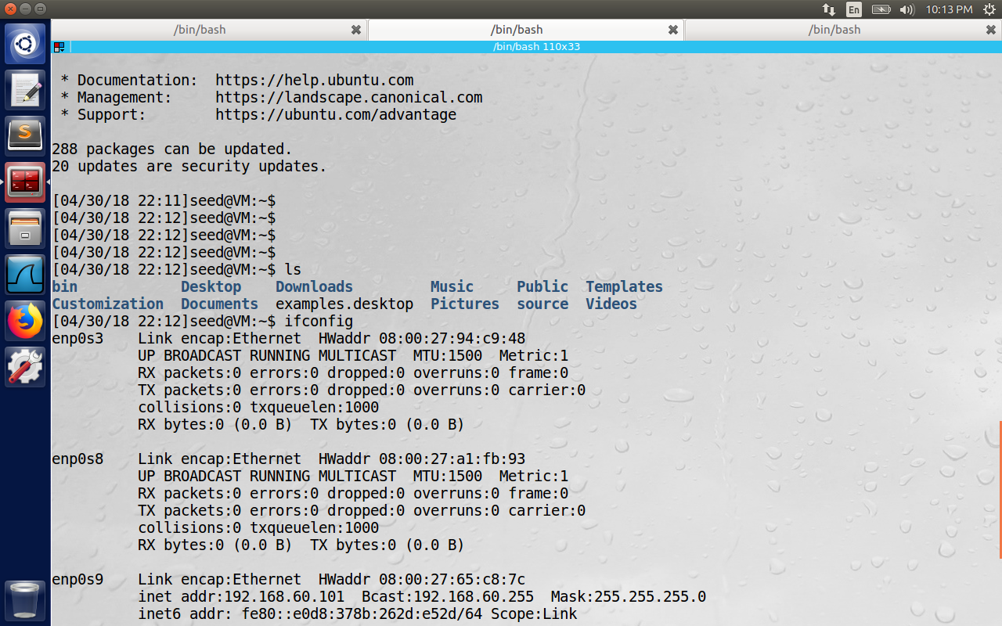

In the above figure telnet session was restored after reestablishing the channel between client and Gateway. Because telnet is TCP based, it will buffer the input and keep on retrying and when the channel is finally available, the data is successfully transferred across the channel.